**FINAL REPORT**

**Capstone Project - The Battle of Neighbourhoods**

**Introduction:**

New York City's demographics show that it is a large and ethnically diverse metropolis. It is the largest city in the United States with a long history of international immigration. New York City was home to nearly 8.5 million people in 2014, accounting for over 40% of the population of New York State and a slightly lower percentage of the New York metropolitan area, home to approximately 23.6 million. Over the last decade the city has been growing faster than the region. The New York region continues to be by far the leading metropolitan gateway for legal immigrants admitted into the United States.

New York City has also been a major point of entry for immigrants; the term "melting pot" was coined to describe densely populated immigrant neighbourhoods on the Lower East Side. As many as 800 languages are spoken in New York, making it the most linguistically diverse city in the world. English remains the most widely spoken language, although there are areas in the outer boroughs in which up to 25% of people speak English as an alternate language, and/or have limited or no English language fluency. English is least spoken in neighbourhoods such as Flushing, Sunset Park, and Corona.

With its diverse culture, comes diverse food items. There are many restaurants in New York City, each belonging to different categories like Chinese, Indian, and French etc.

**Problem:**

To find the answers to the following questions:

Q1) List and visualize all major parts of New York City that has great Indian restaurants.

Q2) What is best location in New York City for Indian Cuisine?

Q3) Which areas have potential Indian Restaurant Market

Q4) Which is the best place to stay if you prefer Indian Cuisine?

**Data Section:**

For this project we use following data:

1. New York city data with boroughs and neighborhoods along with their latitude and longitude.
   1. Data Source : <https://cocl.us/new_york_dataset>
   2. Description: Data contains json file having features like borough, neighborhood and their respective longitude and latitude of New York city (e.g., Bronx, Wakefield, 40.894705, -73.847201)
2. List of Indian restaurants in each neighborhood of New York city with their ratings and other properties.
   1. Data Source: Foursquare API.
   2. Description: Data contains name of venue, neighborhood, borough, rating, category and other features of particular venue. (e.g. Kathi Roll, Bronx, Wakefield, 4.5, Indian Restaurant, etc.)

**Methodology:**

1. We begin by collecting the New York city data from the following link "[https://cocl.us/new_york_dataset"](https://cocl.us/new_york_dataset%22)

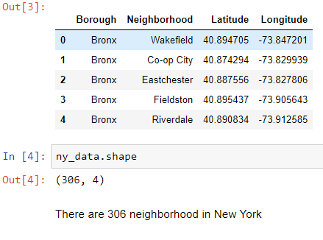

1. We will find all venues for each neighbourhood using Foursquare API

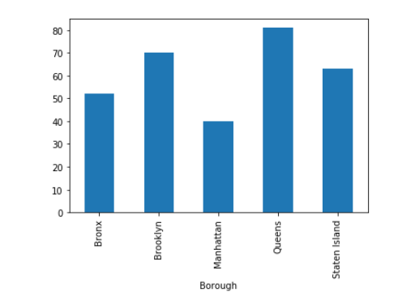

1. We will then filter out all venues with Indian restaurant for further analysis.

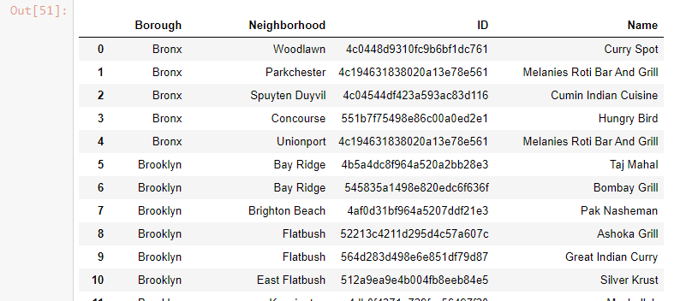

1. Next using Foursquare API, we will find the Ratings, Tips, and Number of Likes for all the Indian Restaurants.

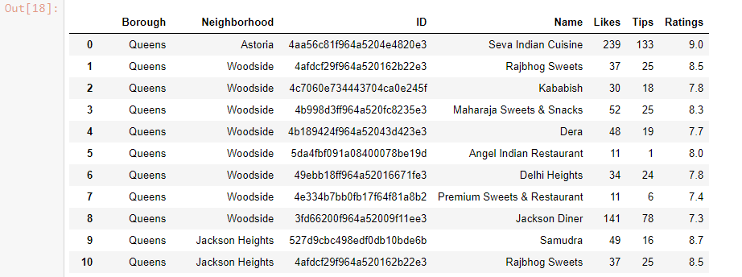

1. We will then sort Neighbourhoods and Borough the data keeping Ratings as the constraint.

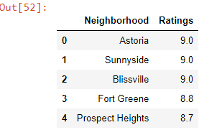

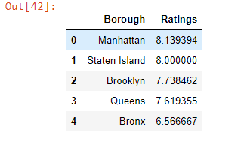

1. Next we will consider the neighbourhoods with highest average ratings to visualize on map.



1. We will join this dataset to original New York data to get longitude and latitude.

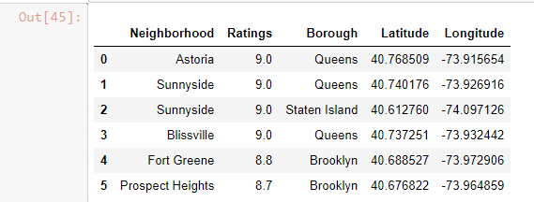

1. Finally, we will visualize the Neighbourhoods and Borough based on average Rating using python’s Folium library.

Neighbourhoods based on average rating:

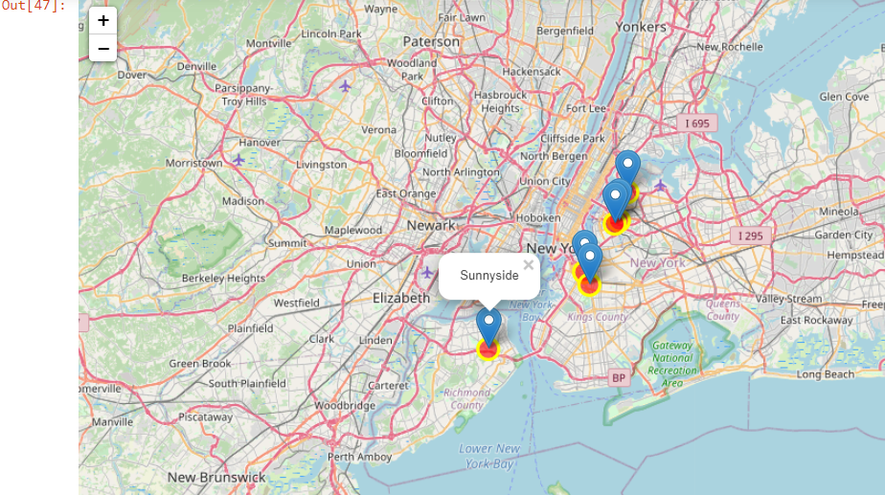

Borough based on average rating:

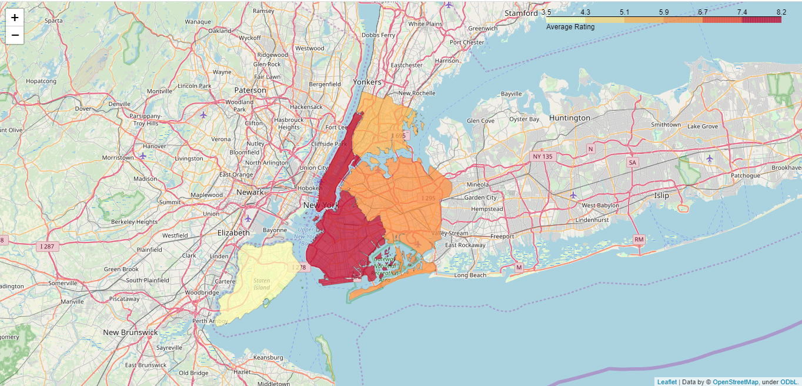

**Result:**

So now we can answer the questions asked above in the Questions section:

Answers:

1. Best restaurant to have Indian food in New York is "Seva Indian Cuisine" in Astoria neighbourhood of Queens.

#### Astoria, Sunny Side, Bliss Ville, Fort Greene and Prospect heights are top 5 neighbourhoods having good Indian cuisine restaurants

#### Manhattan is the best place to stay if you prefer Indian Cuisine.

**Conclusion:**

There is always room for improvement and hence the above solution I have provided can also be improved for best results depending upon the data we have.